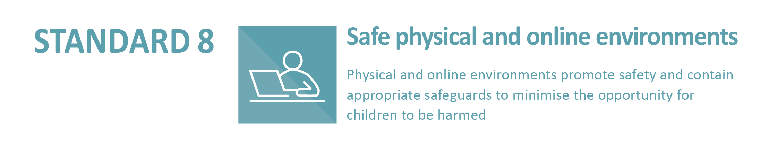
8.4.2 The entity has conducted sufficient due diligence on all third parties who use the entity’s facilities to ensure child safeguarding policies and practices are in place.
Sample Agreement for use when third parties use Church entity premises.
PARTIES
CHURCH ENTITY
Name: [Insert name of Church entity]
Address:

Contact person:
Email:
Phone:

USER OF PREMISES
Name: (User of premises)
Referred to as ‘the User’
Address:

Contact person:
Email:
Phone:
THE PARTIES AGREE
A The [Insert name of Church entity] is the owner of the property at [Insert property address], including the agreed area described as [Describe agreed area e.g. hall, meeting area, carpark, sports oval].
B The [Insert name of Church entity] has, at the request of the User, agreed to permit the User a non-exclusive right to use and occupy the agreed area in accordance with this Agreement.
C The User agrees to use and occupy the agreed areas on the terms and conditions of this Agreement for the permitted use of [Specify User’s purpose e.g. music lessons, craft group].

KEY TERMS OF THE AGREEMENT
1.1 Commencement Date and End Date
This Agreement will continue for the term, commencing on (date) and ending on (date) subject to any earlier termination or extension granted in accordance with this Agreement.
1.2 Licence area to be used
The [Insert name of Church entity] allows the User to use and access the agreed area as identified and any specified furniture, fittings and equipment as described below:

1.3 Scheduled hours
Unless otherwise agreed between the parties, the agreed area will be used only on the following days and times (specify times of day accordingly below)
Monday Tuesday
Wednesday Thursday
Friday
Saturday Sunday
OR (list specific dates and hours)

1.4 Safeguarding children and vulnerable adults
In order to safeguard children, the User must agree to each of the following declarations:
- I/the User I represent, am/is committed to protecting and safeguarding children, young people and vulnerable adults.
- I/the User I represent, have/has a Safeguarding Policy in place and have/has an understanding of safeguarding. A copy of this policy is attached.
- I/the User I represent, have/has read the [Insert name of Church entity]’s Safeguarding Policy and Code of Conduct and will act in accordance with these policies whilst using the licenced area.
- All those who are working or in contact with children during the use of the licenced area have obtained a Working with Children Check.
- I understand that if the User I represent is found to be in breach of this declaration, the [Insert name of Church entity] reserves the right to cancel any leasing or hiring Agreement immediately.
1.5 Cost of hiring
The cost of hire for the licenced area will be calculated as follows:
Usage fee
Utilities
Cleaning
GST
TOTAL

EXECUTION
Signature: Date:
on behalf of User
Name:

Witness Name:
Witness Signature:

Signature: Date:
on behalf of [Insert name of Church entity]
Name:

Witness Name:
Witness Signature:

Adapted from Licence Agreement (Victoria), The Uniting Church in Australia – Synod of Victoria and Tasmania, www.victas.uca.org.au

